Lab 02
Company Database

- Create Database Company
CREATE DATABASE Company ON PRIMARY
( NAME = 'Company',
FILENAME = 'C:\DATA\Company.mdf' ,
SIZE = 3072KB ,
MAXSIZE = UNLIMITED,
FILEGROWTH = 1024KB )
LOG ON
( NAME = 'Company_log',
FILENAME = 'C:\DATA\Company_log.ldf' ,
SIZE = 1024KB ,
MAXSIZE = 2048KB ,
FILEGROWTH = 10%)
Note: Save to file Company_DB.sql

- Create tables – Priamry Key – Foreign Key

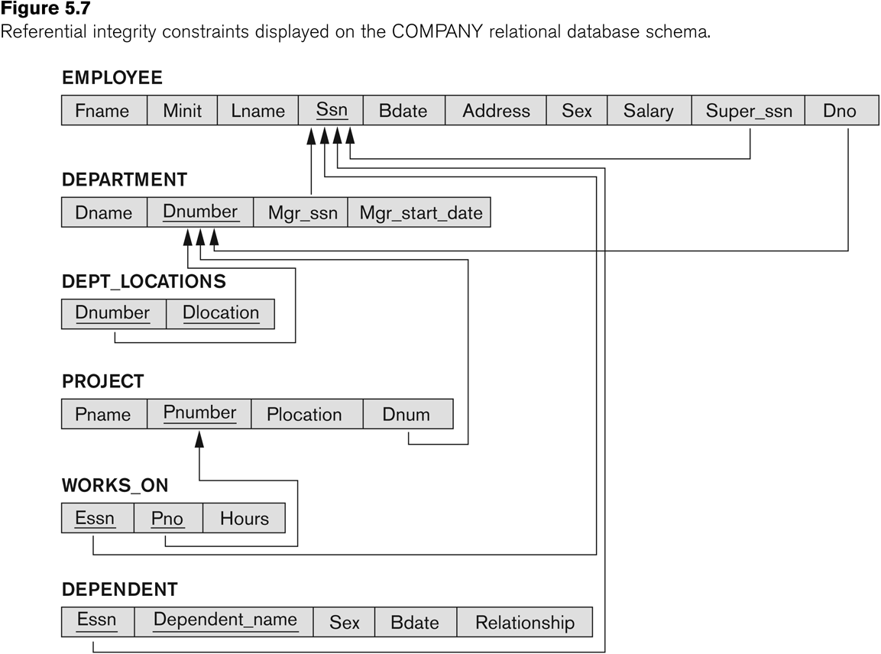

Table Structure:
- Employee
Field Name | Data Type | Null
FName | varchar(15) | NOT NULL
MInit | varchar(1) | NULL
LName | varchar(15) | NOT NULL
SSN | char(9) | NOT NULL
BDate | datetime | NULL
Address | varchar(30) | NULL
Sex | char(1) | NULL
Salary | numeric(10, 2) | NULL
SuperSSN | char(9) | NULL
DNo | numeric(4, 0) | NULL

- Department
Field Name | Data Type | Null
DName | varchar(15) | NOT NULL
DNumber | numeric(4, 0) | NOT NULL
Mgrssn | char(9) | NULL
MgrStartdate | datetime | NULL

- Department Location
Field Name | Data Type | Null
DNumber | numeric(4, 0) | NOT NULL
DLocation | varchar(15) | NOT NULL

- Project
Field Name | Data Type | Null
PName | varchar(15) | NOT NULL
PNumber | numeric(4, 0) | NOT NULL
PLocation | varchar(15) | NULL
DNum | numeric(4, 0) | NOT NULL

- Works on
Field Name | Data Type | Null
ESSN | char(9) | NOT NULL
PNo | numeric(4, 0) | NOT NULL
Hours | numeric(4, 1) | NULL

- Dependent
Field Name | Data Type | Null
ESSN | char(9) | NOT NULL
Dependent_Name | varchar(15) | NOT NULL
Sex | char(1) | NULL
BDate | datetime | NULL
Relationship | varchar(8) | NULL
Note: Save to file Company_Tab.sql
- Insert Data
In 2 tables Employee and Department: when entering data into table, the data is entered first and other is enterd next. After they can update.
- Employee
FName | Minit | LName | SSN | BDate | Address | Sex | Salary | Supper_SSN | DNo
John | B | Smith | 123456789 | 01/09/1955 | Houston, TX | M | 30000 | 333445555 | 5
Franklin | T | Wong | 333445555 | 12/08/1945 | Houston, TX | M | 40000 | 888665555 | 5
Joyce | A | English | 453453453 | 07/31/1962 | Houston, TX | F | 25000 | 333445555 | 5
Ramesh | K | Narayan | 666884444 | 09/15/1952 | Humble, TX | M | 38000 | 333445555 | 5
James | E | Borg | 888665555 | 11/10/1927 | Houston, TX | M | 55000 | NULL | 1
Jennifer | S | Wallace | 987654321 | 06/20/1931 | Bellaire, TX | F | 43000 | 888665555 | 4
Ahmad | V | Jabbar | 987987987 | 03/29/1959 | Houston, TX | M | 25000 | 987654321 | 4
Alicia | J | Zelaya | 999887777 | 07/19/1958 | Spring, TX | F | 25000 | 987654321 | 4

- Department
DName | DNumber | Mgrssn | MgrStartdate
Headquarters | 1 | 888665555 | 06/19/1971
Administration | 4 | 987654321 | 01/01/1985
Research | 5 | 333445555 | 05/22/1978

- Department Location
DNumber | DLocation
1 | Houston
4 | Stafford
5 | Bellaire
5 | Houston
5 | Sugarland

- Project
PName | PNumber | PLocation | DNum
ProductX | 1 | Bellaire | 5
ProductY | 2 | Sugarland | 5
ProductZ | 3 | Houston | 5
Computerization | 10 | Stafford | 4
Reorganization | 20 | Houston | 1
Newbenefits | 30 | Stafford | 4

- Works on
ESSN | PNo | Hours
123456789 | 1 | 32.5
123456789 | 2 | 7.5
333445555 | 2 | 10.0
333445555 | 3 | 10.0
333445555 | 10 | 10.0
333445555 | 20 | 10.0
453453453 | 1 | 20.0
453453453 | 2 | 20.0
666884444 | 3 | 40.0
888665555 | 20 | NULL
987654321 | 20 | 15.0
987654321 | 30 | 20.0
987987987 | 10 | 35.0
987987987 | 30 | 5.0
999887777 | 10 | 10.0
999887777 | 30 | 30.0

- Dependent
ESSN | Dependent_Name | Sex | BDate | Relationship
123456789 | Alice | F | 12/31/1978 | Daughter
123456789 | Elizabeth | F | 05/05/1957 | Spouse
123456789 | Michael | M | 01/01/1978 | Son
333445555 | Alice | F | 04/05/1976 | Daughter
333445555 | Joy | F | 05/03/1948 | Spouse
333445555 | Theodore | M | 10/25/1973 | Son
987654321 | Abner | M | 02/29/1932 | Spouse

Note: Save to file Company_Data.sql

